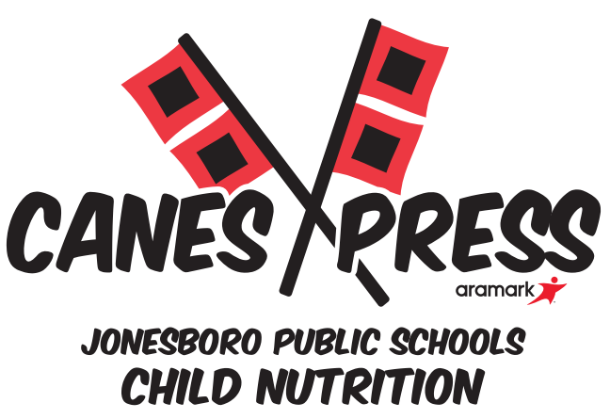

**Field Trip Meal Request**

School Requesting Field Trip Meals:_____________________________________________

**\*\*\*\*\*\*\*\*\*\*\*\*\*\*\*\*\*\*\*\*\*\*\*\*\*\*\*ATTENTION\*\*\*\*\*\*\*\*\*\*\*\*\*\*\*\*\*\*\*\*\*\*\*\*\*\*\*\*\***

**All orders must be placed one week in advance**

**Section I**

|  |  |
| --- | --- |
| **Teachers Full Name** |  |
| **Date of Request** |  |
| **Date of Field Trip** |  |
| **Total Number of Students** |  |
| **Field Trip Meals Requested** |  |
| **# of White Milk** |  |
| **# of Chocolate Milk** |  |
| **Time of Meals will be needed** |  |

Grab & Go breakfasts & lunches are available for students to take on field trips.

***Breakfast Lunch***

Cold Entrée Cold Entree

**\*\*Adult Breakfast $2.50 **Adult Lunch $4.75**

**Meals will be ready and waiting on the morning of the field trip.**

**\*\*Please provide rosters with student names for each meal ordered\*\***

**Section II (Food Service Only)**

|  |  |
| --- | --- |
| **Number of Meals Prepared** |  |
| **Number of Coolers** |  |

**Section III (Food Service Only)**

|  |  |
| --- | --- |
| **Number of Meals Posted in POS** |  |
| **Number of Meals Retuned** |  |

In accordance with Federal law and U.S. Department of Agriculture (USDA) civil rights regulations and policies, this institution is prohibited from discriminating on the basis of race, color, national origin, sex, age, disability, and reprisal or retaliation for prior civil rights activity. (Not all prohibited bases apply to all programs.)Programinformation may be made available in languages other than English. Persons with disabilities who require alternative means of communication for program information (e.g., Braille, large print, audiotape, and American Sign Language) should contact the responsible State or local Agency that administers the program or USDA’s TARGET Center at (202) 720-2600 (voice and TTY) or contact USDA through the Federal Relay Service at (800) 877-8339. To ­le a program discrimination complaint, a complainant should complete a Form AD-3027, USDA Program Discrimination Complaint Form, which can be obtained online, at www.usda.gov/sites/default/­les/documents/usda-programdiscrimination-complaint-form.pdf, from any USDA o‑ce, by calling (866) 632-9992, or by writing a letter addressed to USDA. The letter must contain the complainant’s name, address, telephone number, and a written description of the alleged discriminatory action in su‑cient detail to inform the Assistant Secretary for Civil Rights (ASCR) about the nature and date of an alleged civil rights violation. The completed AD-3027 form or letter must be submitted to USDA by: mail: U.S. Department of Agriculture O‑ce of the Assistant Secretary for Civil Rights 1400 Independence Avenue, SW Washington, D.C. 20250-9410; or fax: (833) 256-1665 or (202) 690-7442; email: program.intake@usda.gov | This institution is an equal opportunity provider.